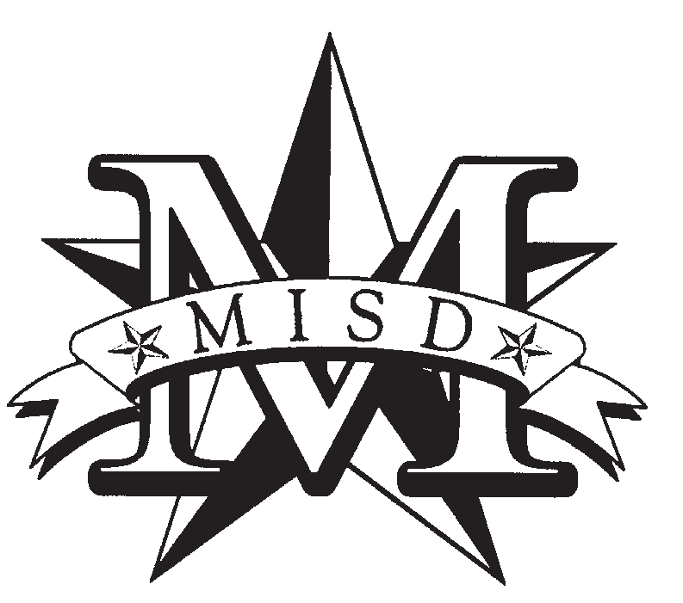
Mesquite ISD 2020 - 2021 Free and Reduced Meal Program

APPLY ONLINE AT www.schoolcafe.com

Dear Parent/Guardian:
Children need healthy meals to learn. Mesquite ISD offers healthy meals every school day. Breakfast costs
$1.80 for all students; lunch costs $2.50 for elementary, $2.80 for middle school and $2.90 for high school students. Your children may qualify for free meals or for reduced-price meals. Reduced price is $0.30 for breakfast and $0.40 for lunch. If you received a notification letter that a child is directly certified for free meals, DO NOT complete an application. Call Meal Benefits at 972-882-5512 if any children in the household attending school are not listed in the notification letter.
The questions and answers that follow provide additional information on how to complete the application. Com- plete one application per household, even if the children in the household attend more than one school in Mesquite ISD. For faster processing submit an application online at www.schoolcafe.com. If you have questions about ap- plying for free or reduced-price meals call Meal Benefits 972-882-5512.

Who can get free meals?
  - Income - Children can get free or reduced-priced meals if a household’s gross income is within the limits described in the Federal Income
Eligibility Guidelines.
  - Special Assistance Program Participants - Children in households receiving benefits from the Supplemental Nutrition Assistance Program (SNAP), Food Distribution Program for households on Indian Reservations (FDPIR), or Temporary Assistance for Needy Families (TANF), are eligible for free meals.
  - Foster - Foster children who are under the legal responsibility of a foster care agency or court are eligible for free meals.
  - Head Start or Early Start (Floyd Elem ONLY) - Children participating in these programs are eligible for free meals.
  - Homeless, Runaway, and Migrant - Children who meet the definition of homeless, runaway, or migrant qualify for free meals. If you haven’t been told about a child’s status as homeless, runaway, or migrant or you feel a child may qualify for one of these programs, please call your student’s school administrative assistant or counselor.
  - WIC Recipient - Children in households participating in WIC may be eligible for free or reduced-price meals.
- What if I disagree with the school’s decision about my application? You may talk to school officials. You may also ask for a hearing by calling or writing to Lark Stewart, Director of Food and Nutrition Services, 405 E. Davis, Mesquite, TX 75149, 972-882-5500.

My child’s application was approved last year.
Do I need to fill out a new one? Yes. An application is only good for that school year and for the first few days of this school year. Submit online a new application unless Meal Benefits told you that your child is already eligible for the new school year.
- If I don’t qualify now, may I apply later? Yes. Apply at any time during the school year. A child with a parent or guardian who becomes unemployed may become eligible for free and reduced-price meals if the household income drops below the income limit.
- What if my income is not always the same? List the amount normally received. If a household member lost a job or had hours/wages reduced, use current income.
- We are in the military. Do we report our income differently? Basic pay and cash bonuses must be reported as income. Any cash value allowances for off-base housing, food, or clothing or Family Subsistence Supplemental Allowance payments count as income. If housing is part of the Military Housing Privatization Initiative, do not include the housing allowance as income. Any additional combat pay resulting from deployment is excluded
from income.

May I apply if someone in my household is not a
U.S. citizen? Yes. You, your children or other household members do not have to be U.S. citizens to apply for free or reduced-price meals.
- Will application information be checked? Yes. We may also ask you to send written proof of the reported household income.
- My family needs more help. Are there other programs we might apply for? To find out how to apply for other assistance benefits, contact your local assistance office or dial 2-1-1.
- Can I apply online? Yes! The online application has the same requirements and will ask you for the same information as the paper application.
Visit www.schoolcafe.com to begin or to learn more about the online application process.

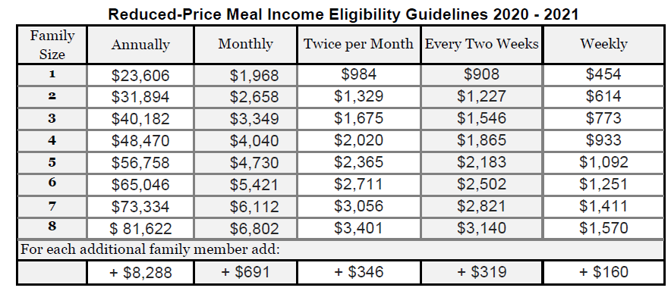
If you have any other questions or need help, call Meal Benefits 972-882-5512. Si necesita ayuda, por favor llame al teléfono: Meal Benefits 972-882-5512.
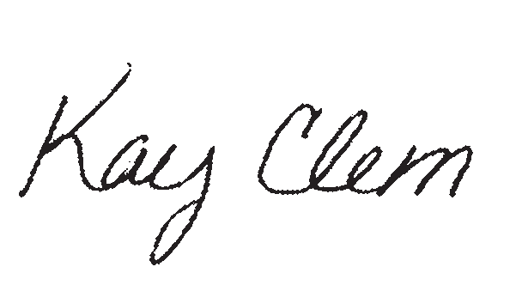
Free and Reduced Meal Program
Sincerely,
Food and Nutrition Services Phone: 972-882-5512
Email: foodnutrition@mesquiteisd.org

